**Requirement Analysis**

**Data Flow Diagram & User Stories**

|  |  |
| --- | --- |
| Date | 01 February 2025 |
| Team ID |  |
| Project Name | Eye Disease Detection Using Deep Learning |
| Maximum Marks | 4 Marks |

**Data Flow Diagrams:**

A Data Flow Diagram (DFD) is a traditional visual representation of the information flows within a system. A neat and clear DFD can depict the right amount of the system requirement graphically. It shows how data enters and leaves the system, what changes the information, and where data is stored.

**Level 1 DFD:**

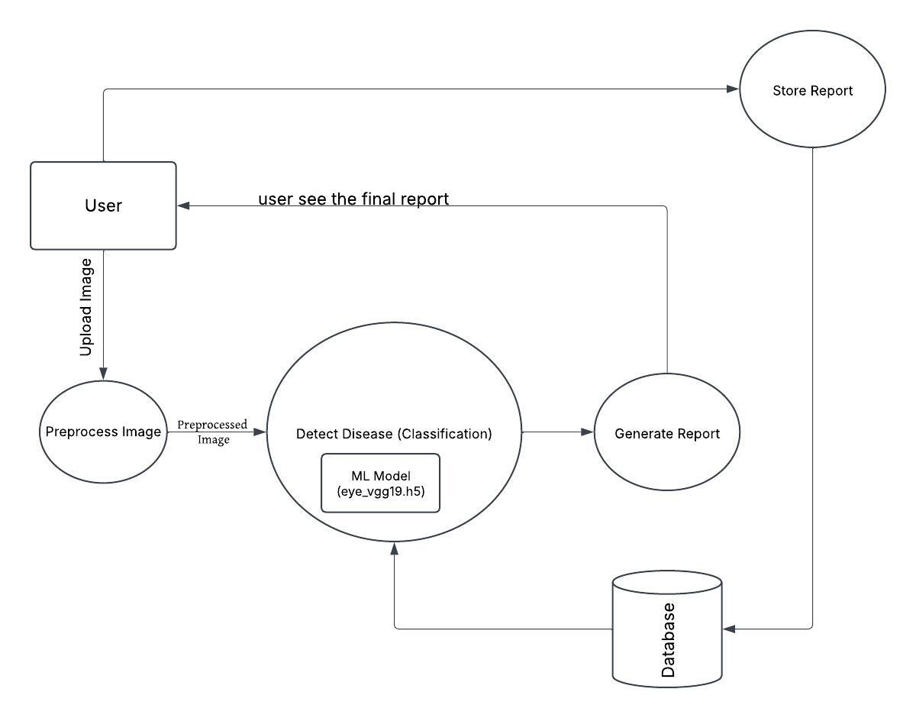

**User Stories**

**User Stories Table**

|  |  |  |  |  |  |  |
| --- | --- | --- | --- | --- | --- | --- |
| **User Type** | **Functional Requirement (Epic)** | **User Story Number** | **User Story / Task** | **Acceptance Criteria** | **Priority** | **Release** |
| **Customer (Mobile user)** | **Registration** | USN-1 | As a user, I can register for the application by entering my email, password, and confirming my password. | I can access my account/dashboard. | High | Sprint-1 |
|  |  | USN-2 | As a user, I will receive a confirmation email once I have registered for the application. | I can receive a confirmation email & click confirm. | High | Sprint-1 |
|  |  | USN-3 | As a user, I can register for the application through Facebook. | I can register & access the dashboard with Facebook Login. | Low | Sprint-2 |
|  |  | USN-4 | As a user, I can register for the application through Gmail. | I can register & access the dashboard with Gmail Login. | Medium | Sprint-1 |
| **Login** | **Authentication** | USN-5 | As a user, I can log into the application by entering my email & password. | I can successfully log in to my account. | High | Sprint-1 |
|  |  | USN-6 | As a user, I can reset my password if I forget it. | I can receive a reset link and change my password. | High | Sprint-2 |
| **Dashboard** | **View Reports** | USN-7 | As a user, I can view my past eye disease reports. | I can see a list of past predictions and their details. | High | Sprint-1 |
|  | **Upload Image** | USN-8 | As a user, I can upload an eye image for disease detection. | I can upload an image & see the results. | High | Sprint-1 |
|  | **Receive Prediction** | USN-9 | As a user, I can receive a disease prediction based on the uploaded image. | I can see the detected disease & confidence score. | High | Sprint-1 |
|  | **Download Report** | USN-10 | As a user, I can download my diagnosis report as a PDF. | I can successfully download a formatted report. | Medium | Sprint-2 |
| **Customer (Web user)** | **Profile Management** | USN-11 | As a user, I can edit my profile details like name, email, and password. | I can update my details successfully. | Medium | Sprint-2 |
|  | **View History** | USN-12 | As a user, I can check my past uploads and their results. | I can see a history of my disease detections. | High | Sprint-1 |
| **Customer Care Executive** | **Support Requests** | USN-13 | As a support executive, I can view user queries and complaints. | I can access a dashboard of user requests. | Medium | Sprint-3 |
|  | **Respond to Queries** | USN-14 | As a support executive, I can respond to user questions via chat or email. | Users receive timely responses to their queries. | Medium | Sprint-3 |
| **Administrator** | **Manage Users** | USN-15 | As an admin, I can block or unblock user accounts if needed. | I can manage user access and restrictions. | High | Sprint-2 |
|  | **Monitor System Performance** | USN-16 | As an admin, I can track system performance and server load. | I can see analytics & performance metrics. | Medium | Sprint-3 |